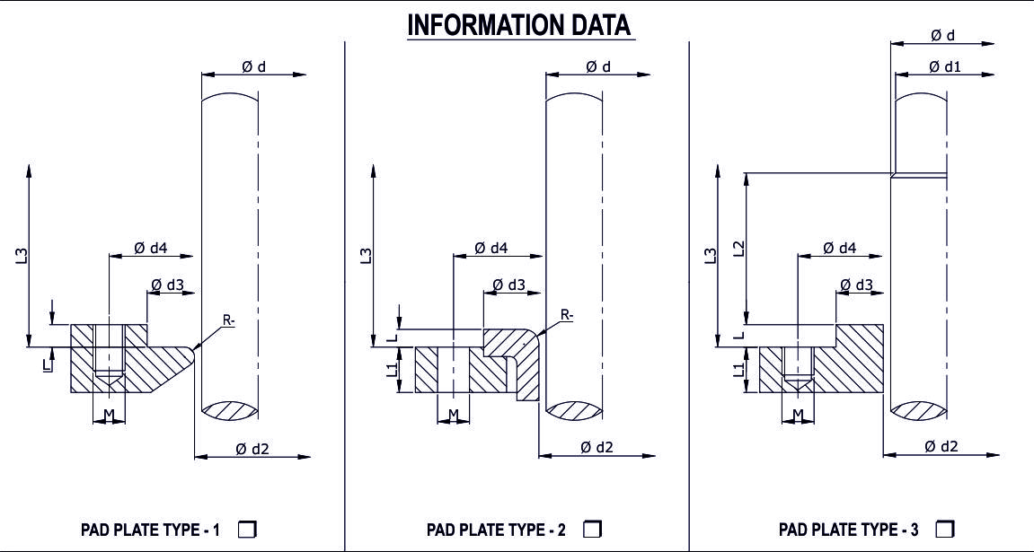

d - Shaft OD .................................................  d1 - Shaft OD .................................................  d2 - Pad Plate ID............................................  d3 - Spigot ID / OD.........................................  d4 - Bolt Circle ............................................... | M - No. of Bolts ....................Size...............  L - Raised Collar .........................................  L1 - Thickness................................................  L2 - Shaft step from Pad plate .......................  L3 - Nearest obstruction ................................

REACTOR-AGITATOR-MIXER DATA

CLIENT NAME

MAKE: MODEL:

EQPT NO: M.O.C OF VESSEL & SHAFT:

TOP ENTRY BOTTOM ENTRY SIDE ENTRY

FLUID DETAILS & OPERATING PARAMETERS

MEDIA:

PRESSURE (Kg/cm²): TEMP (°C):

RPM: DIRECTION OF ROTATION (VIEW FROM MOTOR END): CW ACW

REMARKS (IF ANY):

Please √ Confirm Direction Bolt To Give Easy Flushing &Quinching

